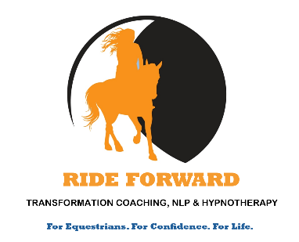
RIDE FORWARD COACHING

TERMS AND CONDITIONS

Coach and Client hereby agree:

The coach refers to Julia Barry of Ride Forward Coaching
The client refers to the person who has paid for coaching with Ride Forward Coaching.

Sessions
Sessions last between 60 and 90 minutes and will take place on zoom unless prior arrangements have been made to meet face to face.

Your Choice, Your Responsibility
Client authorises Coach to produce a coaching session based on the Client’s information given in the discovery questionnaire for coaching. Please note that it is the Client’s responsibility to disclose any new or existing physical and/or psychological issues to the practitioner prior to the start of any coaching sessions. Should a Client disclose information which could indicate that their personal safety is at risk, and/or a Safeguarding issue raised, the Practitioner is required to share this information with the relevant authorities. Please note that hypnotherapy is not suitable for individuals with epilepsy or other similar neurological conditions.
Client understands that the success of his/her session depends on their ability and desire to effect change within myself. Client acknowledges that Coach will do her utmost to ensure client’s success, though no guarantee can be made. Client hereby agrees that whatever is discussed is based on Coach’s training and is not binding upon the Client, nor is it a prescription. Coach’s liability is limited to the amount paid to her for the agreed session.

This is Coaching or Complementary Therapy
Coach is not a licensed GP, Psychologist or Psychiatrist. The services Client receives are not regulated by a government body. Coach has been trained and certified in Transformation Coaching, NLP, Time Line Therapy, Hypnosis and Somatic Coaching at the Practitioner level. Coach will always provide only those services in which she has been trained, and if she finds that she cannot help client, she will refer them to someone who can assist them.
Confidentiality
Coach only gathers information which is necessary to create and deliver your session. Coach keeps all information she receives from client confidential and does not disclose it to persons outside RideForward Coaching. All client information is kept strictly confidential, stored in compliance with the terms of GDPR. and is for internal use only.
Payment & Packages
Bookings must be made in advance and cannot be confirmed until payment is made.
Cancellation & Refund Policy
Clients cancelling appointments will be given the option to move to another time or refunded in full unless cancellations are within 48 hours of the appointment. After this time refunds will be at 50% due to the workload creating bespoke packages and hypnotherapy sessions.

