YH Camp Ride Forward Booking Form
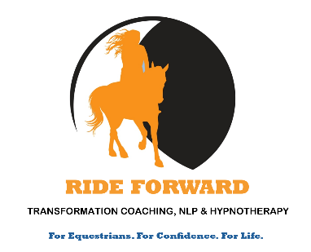
Please fill out the following form stating which package you would like to book. All information is kept strictly confidential.
If you prefer, you can even book a free no-obligation chat with me to see which package fits your needs.
Please email your completed form to: info@rideforwardcoaching.co.uk
Personal Information
Name:
Contact details: Phone
Email
I would like to book a free no-obligation chat with you first.

I would like to book:

Silver package (a 40 minute bespoke session specially for you which
includes a personal written guide that you can take away with you) £35
Gold package (a 1 hour bespoke more in depth session with access to
more techniques, including your personal written guide) £50
Platinum package (a I hour 15min bespoke package specially for you
which includes a coaching session with your own take away written
guide and a 45 minute hypnotherapy session with your special
hypnotherapy recording to listen to in the week before camp) £70

My preferred time slot is: Day: a.m. or p.m.:

I will receive my pre-coaching questionnaire by return email and am
happy to complete it so that my package can be bespoke to my needs.

I have signed the terms and conditions on the next page.

I have paid into the following bank account and understand that my
booking is not be confirmed until payment has been made:
Ms J Dalby Sort Code 401824 Account Number 21737279
Reference: Your Name
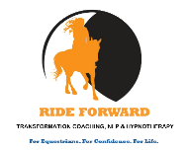
Ride Forward Coaching Client Agreement
This agreement sets out the conditions and understandings for a coaching relationship between Julia Barry (nee Dalby) (Coach) and ___________________________________ (Client).
Coach and Client hereby agree:
Coach and Client will meet face to face for their coaching session at YH Camp. Client has the option to book and pay for further coaching on zoom or face to face if they live close by.

Your Choice, Your Responsibility
Client authorises Coach to produce a coaching session based on the Client’s information given in the discovery questionnaire for coaching. Please note that it is the Client’s responsibility to disclose any new or existing physical and/or psychological issues to the practitioner prior to the start of any coaching sessions. Should a Client disclose information which could indicate that their personal safety is at risk, and/or a Safeguarding issue raised, the Practitioner is required to share this information with the relevant authorities. Please note that hypnotherapy is not suitable for individuals with epilepsy or other similar neurological conditions.
Client understands that the success of his/her session depends on their ability and desire to effect change within myself. Client acknowledges that Coach will do her utmost to ensure client’s success, though no guarantee can be made. Client hereby agrees that whatever is discussed is based on Coach’s training and is not binding upon the Client, nor is it a prescription. Coach’s liability is limited to the amount paid to her for the agreed session.

This is Coaching or Complementary Therapy
Coach is not a licensed GP, Psychologist or Psychiatrist. The services Client receives are not regulated by a government body. Coach has been trained and certified in Transformation Coaching, NLP, Time Line Therapy, Hypnosis and Somatic Coaching at the Practitioner level. Coach will always provide only those services in which she has been trained, and if she finds that she cannot help client, she will refer them to someone who can assist them.
Confidentiality
Coach keeps all information she receives from client confidential and does not disclose it to persons outside RideForward Coaching. All client information is kept strictly confidential and is for internal use only.
Payment & Packages
Bookings must be in advance and cannot be confirmed until payment is made.
Cancellation & Refund Policy
Appointments cancelled before 23rd April will receive a full refund. After this time refunds will be at 50% due to the workload creating bespoke packages and hypnotherapy sessions.
If client is unable to attend camp for any reason, they may choose either a 1:1 zoom session within a month of the date of camp or a refund in full with the exception of hypnotherapy bookings where the recording has already been sent to the client. These will be refunded at 50% of the original price.
Please feel completely free to contact me if you would like to discuss any of the above further info@rideforwardcoaching.co.uk
I have read and agree to the T&Cs stated above:
Coach: Julia Barry (nee Dalby) Date: 10/04/25 Client: ________________________Date: _________

